To Whom It May Concern,
We are delighted to confirm that [STUDENT NAME] will be taking part in a Venture Force Expedition to [LOCATION] in [MONTH,YEAR] as part of a team from [SCHOOL NAME].
The expedition is being facilitated by ourselves; Venture Force. We are a small expeditions company based in the East Midlands and take a relatively small number of students each year away on expeditions all over the world. As a small company we pride ourselves in offering bespoke expeditions which are designed to help the students develop personally, widen their understanding of other cultures and develop key life skills including organisation, communication and teamwork. In addition, the expeditions include really worthwhile and sustainable community and conservation projects which we put a lot of time and effort into planning. We really get involved with the host community and help them to do something that means something! We don’t just turn up and paint a wall.
One of the biggest challenges facing the students who take part in our expeditions is raising the necessary funds. We strongly encourage all of our participants to take ownership of their expedition and fundraise for it creatively. It is a challenge, especially as the students are balancing their fundraising and training for expedition with their academic and other commitments.
This experience really is a once in a lifetime one and the skills development and experiences these young people gain go a long way to shaping their future.
We thank you for any support provide.
Kind regards,

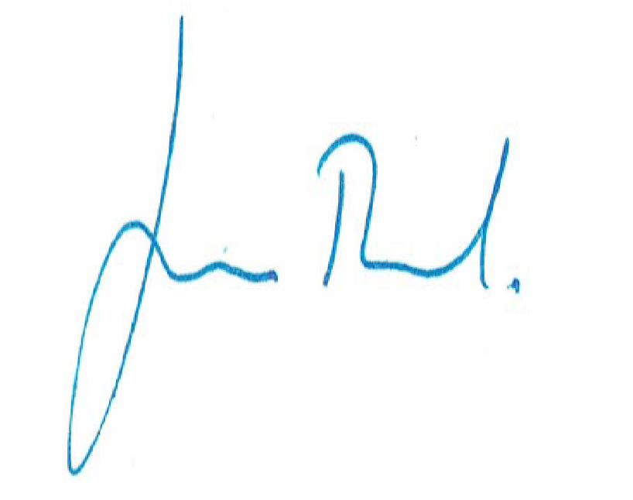
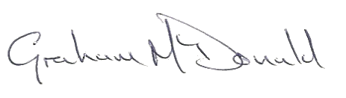

Tom Tuckwood and Graham McDonald
Venture Force Directors

